COMPREHENSIVE SPINE CARE, P.A.
PAIN DIAGRAM

NAME_________________________________________ DATE___________________
WHERE IS YOUR PAIN NOW?
MARK THE AREAS ON YOUR BODY WHERE YOU FEEL THE DESCRIBED SENSATIONS
ACHE NUMBNESS PINS & NEEDLES BURNING STABBING
AAA OOO ---- XXX IIII
AAA OOO ---- XXX IIII
AAA OOO ---- XXX IIII

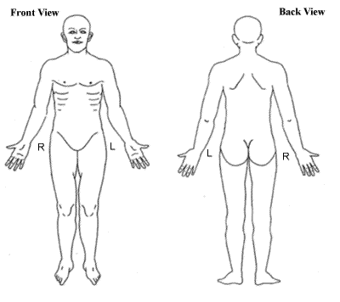
PAIN SCALE
(CIRCLE ONE)

1-2-3-4-5-6-7-8-9-10

MINIMUM-----------------MAXIMUM

